**Unit 8 Cheat Sheet**

2D arrays are arrays with two dimensions.

|  |  |  |
| --- | --- | --- |
| Rows  →  →  → | Colomuns ↓ ↓ | |
|  |  |
|  |  |
|  |  |

Row Major vs Column Major

*Java uses row-major order. C land Python also use row-major order. Matlab uses column major. The difference is in how the arrays are stored in the memory, It doesn’t really matter which one is used.

Creating a 2D array:

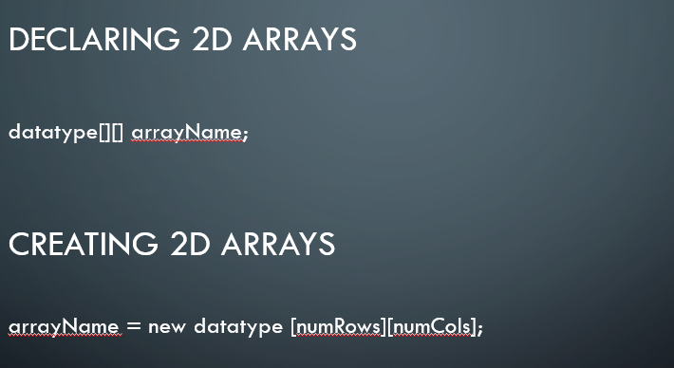

*You can set values for the array when you create it.

*You don’t need to specify the size in this case.

Example:

String[][] grades = { {“Math”,”History”,”Literature”},{“88”,”24”,”62”}};

Accessing elements:

Example:

System.out.println(VarName[rowIndex][colIndex]);

Editing elements:

Example:

VarName[rowIndex][colIndex]=3;